***An Overview of various loan schemes offered***

***by***

***Jammu & Kashmir Bank Pvt Ltd***

***Submitted by***

***Shafia Nabi***

*in partial fulfillment for the award of the degree*

*of*

***Bachelors in Business Administration***

*in*



***Business School,***

***SSM College of Engineering***

***University of Kashmir***

*Session 2020-21*

*i*

***CERTIFICATE***

***Certified that this Report on Various Loan Schemes offered by***

***Jammu and Kashmir Bank Pvt Ltd***

***Being submitted herewith to***

***Business School, SSM College of Engineering***

***is the bonafide work of***

***Shafia Nabi***

***who carried out the project work under our guidance and supervision.***

| ***Ms. Nahida Hassan***  *Guide* | ***Mr. Ajaz Mistri***  *Head of the Department* | ***Dr. N.A. Shah***  *Director Business School* |
| --- | --- | --- |

***BBA***

***SSM College of Engineering***

***University of Kashmir***

*ii*

***Acknowledgement***

*At the beginning I am very much grateful to the Almighty Allah for giving me the strength to complete the report properly. Without the blessings of my Almighty, it would never be possible for me to complete both the internship period and this internship report successfully.*

*A special thanks and gratitude goes to my Internship’s supervisor* ***Prof Ajaz Mistri****.*

*Without his valuable supervision and direction, it would not have been possible to complete this report.*

*Then I would like to express my heartfelt gratitude to the National Bank Limited, Muradpur branch for giving me a chance to complete my internship program at their branch, for allowing me to gather information and helping me in every possible way in preparing the internship report. My endless thanks to* ***Mr. Parvaiz Ahmad (****branch head). I worked with* ***Ms. Deeba Din****(Advance Insurance manager) and* ***Ms. Nahida Hassan*** *(Advance Incharge). Besides them, all the colleagues of the branch had been*

*very helpful and they made my internship period more enjoyable and eventful one. It really makes students capable of doing official tasks before entering the corporate world.*

|  |  |
| --- | --- |

*iii*

***TABLE OF CONTENTS***

|  | ***TITLE*** | ***Page No.*** |
| --- | --- | --- |
|  | *Cover Page* | *i* |
|  | *Certificate* | *ii* |
|  | *Acknowledgement* | *iii* |
|  | *Table of Content* | *iv* |
|  | *List of Tables* | *vi* |
|  | *List of Figures* | *vii* |
|  | *List of symbols and abbreviations* | *viii* |
| ***1.0*** | ***INTRODUCTION*** | ***1*** |
|  | *1.1 Origin of Report* | *1* |
|  | *1.2 Objectives* | *1* |
| ***2.0*** | ***COMPANY PROFILE*** | ***2*** |
|  | *2.1 Overview* | *2* |
|  | *2.2 Vision & Mission* | *2* |
| ***3.0*** | ***PROJECT WORK*** | ***3*** |
|  | *3.1 Personal loans* | *3* |
| ***4.0*** | *3.2 Business loans*  *3.3 Agricultural loans*  ***CASE STUDY*** | *3*  *3*  ***4*** |
|  | *iv* |  |
|  |  |  |
|  |  |  |
| ***5.0***  *5.1* | ***CONCLUSION***  *Recommendation* | ***5***  *5* |
| ***6.0*** | ***REFERENCES*** | ***6*** |
|  |  |  |
|  |  |  |
|  |  |  |

*v*

***LIST OF TABLES***

| ***Table No.*** | ***Title*** |  |
| --- | --- | --- |
| *Table 1.1* | *Financial Growth of J&K Bank (FY 2019-21)* |  |
| *Table 2.1* | *Ranking of J&K Bank in providing lowest HL Interest rates* |  |
|  |  |  |

*vi*

***LIST OF FIGURES***

| ***Figure No.*** | ***Title*** | ***Page No****.* |
| --- | --- | --- |
| *Figure 1.1* | *Credit to deposit ratio of J&K Bank (FY 2017 and 2021)* | *1* |
| *Figure 1.1* | *Financial Ratio (Burden - Total Assets)* | *2* |
|  |  |  |

*vii*

***LIST OF SYMBOLS AND ABBREVIATIONS***

| ***Symbol*** | ***Explanation*** |
| --- | --- |
| *$*  *Pvt*  *Ltd*  *i.e*  *ROI*  *Govt.* | *Dollar*  *Private*  *Limited*    *That is*  *Rate Of Interest*  *Government* |
| *FY*  *Agri* | *Financial Year*  *Agriculture* |

*viii*

***1. INTRODUCTION***

***1.1 Origin of the report***

*This internship report is submitted after completing 6 weeks of internship at J&K Bank Limited. It includes the major job responsibilities and also a project on specific process*

*i.e “Various loan schemes offered by J&K Bank”.*

*The Report also includes an overview of J&K Bank Ltd. Moreover, it describes the major responsibilities and observations of mine through the internship period in J&K Bank Ltd.*

*The purposes of the Internship Program are as follows:*

* *Internship will give the students Opportunity to develop their skill in the application of theory to practical work situations.*
* *Internships will provide students with an in-depth knowledge of the formal functional activities of a participating organization*
* *Internship will increase a student’s sense of responsibility.*
* *Internship will also provide students the opportunity to develop attitudes conducive to effective interpersonal relationships.*
* *Internship also helps the students to assess their career in their chosen sector.*

***1.2 Objectives***

***General Objective:***

*The general objective of the study is to fulfill requirement of the Graduation under the*

*Bachelor of Business Administration program of University of Kashmir as per university policy.*

***Specific Objective:***

*The specific objective of this reports are:*

*1. To bring together information regarding the entire process of credit approval*

*2. To achieve knowledge regarding the system of credit risk assessment.*

*1*

***2. COMPANY PROFILE***

***2.1 Overview***

*Jammu and Kashmir Bank (J&K Bank) is a scheduled commercial bank and one of the oldest private sector banks in India, incorporated in 1938. The Bank is listed on NSE and the BSE and has its Corporate Headquarters at Srinagar.*

*It functions as a leading bank in the Union Territories of J&K and Ladakh and is designated by Reserve Bank of India as its exclusive agent for carrying out banking business for the govt. of J&K and Ladakh. J&K bank caters to banking requirements of various customer segments which includes Business enterprises, employees of government, semi-government and autonomous bodies, farmers, artisans, public sector organizations and corporate clients. The bank also offers a wide range of retail credit products, including home, personal loans, education loan, agriculture, trade credit and consumer lending, a number of unique financial products tailored to the needs of various customer segments.* 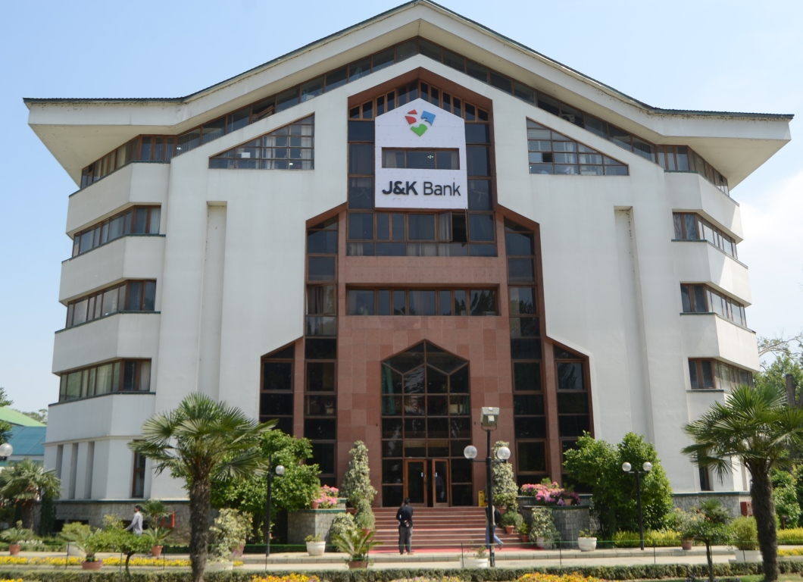

*Figure 2.1 : Title of the image*

***2.2 Vision & Mission***

***Vision:***

***“Pioneering the economic and social transformation”***

*To become a committed partner in fostering economic and social transformation across the country through a deep commitment to value creation for all our stakeholders, while continuing to build on our historic business relationship with Jammu & Kashmir and Ladakh.*

***Mission:***

* *To acquire an enhanced business footprint across geographies and emerge as a prominent national brand in the financial sector.*
* *To position the Bank as the “Most Preferred Bank” for Customer focus, Operational Excellence and High Integrity towards one and all stakeholders.*
* *To be the best-in-class financial intermediary, leveraging our digital and physical banking channels;*
* *To observe customer centricity through service excellence, integrity and transparency, and a comprehensive range of innovative products and services responsive to customer needs.*
* *To be a lean, learning and efficient banking organization focusing on prudent, sustainable, profitable growth and value creation.*
* *To adopt the best standards for corporate governance, business ethics and risk management.*
* *To vigorously promote financial inclusion as a business proposition to harness the potential at the bottom of the pyramid.*

*2*

***3. PROJECT WORK***

***Various loan schemes offered by J&K Bank Pvt Ltd***

*Firstly, the term* ***Loan*** *is simply an advance provided for business purposes that needs to be paid back within a specified time frame. It typically carries a fixed interest rate, monthly or quarterly repayment schedule and includes a set maturity date. Term loans can be both secure (i.e. some collateral is provided) and unsecured. A secured term loan will usually have a lower interest rate than an unsecured one. Depending upon the repayment period this loan type is classified as under:*

* *Short term loan: Repayment period less than 1 year.*
* *Medium term loan: Repayment period between 1 to 3 years.*
* *Long term loan: Repayment period above 3 years.*

*3*

***Different types of loans provided by J&K Bank are as follows:***

***1. Personal loans :*** *Education loan Scheme*

*Consumer loan*

*Two-Wheeler finance,etc.*

***2. Business loans:*** *Start-ups finance*

*Commercial vehicle finance*

*Dastkar finance, etc.*

***3. Agricultural loan:*** *Giri Finance*

*Fruit advances scheme (Apple),etc.*

*3*

***3.1 Personal loans***

*A personal loan (also known as a consumer loan) describes* ***any situation in which an individual borrows money for personal need, including making investments in a company****. All personal loans have three common elements: Evidence of the debt (promissory note) An amount borrowed (principal).*

***3.1.1 Education Loan Scheme***



#### ***Purpose***

* *Finance the requirements for higher studies in India or abroad.*

#### [***Eligibility***](https://www.jkbank.com/loans/personal/customerEducationalLoans.php#accordion1_2)

* *Should be an Indian National*
* *Should have secured admission to a higher education course in recognized institutions in India or Abroad through Entrance Test/ Merit Based Selection process after completion of HSC(10 plus 2 or equivalent).*

#### 

#### *3.1*

#### 

#### ***[Age](https://www.jkbank.com/loans/personal/customerEducationalLoans.php#accordion1_3)***

* *There is no specific restriction with regard to the age of the student to be eligible for an education loan.*
* *The upper age limit shall be capped at 35 years, which can be relaxed on a case to case basis.*

#### 

#### [***Courses Eligible***](https://www.jkbank.com/loans/personal/customerEducationalLoans.php#accordion1_4)

* ***Studies in India ( Indicative List) :***
  + *Approved regular courses leading to Graduate/ Post graduate degree and PG diplomas conducted by Recognized Colleges/ Universities recognized by UGC/ Govt. / AICTE/ AIBMS/ ICMR etc.*
  + *Professional Courses in Engineering, Medical, Agriculture, Veterinary, Law, Dental, Management, Computer etc.*
  + *Courses like ICWA, CA, CFA etc.*
  + *Courses conducted by IIM, IIT, IISc, XLRI. NIFT, NID etc.*
  + *Regular Degree/Diploma courses like Aeronautical, pilot training, shipping, degree/diploma in nursing or any other discipline approved by Director General of Civil Aviation/Shipping/Indian Nursing Council or any other regulatory body as the case may be, if the course is pursued in India.*
  + *Approved courses offered in India by reputed Foreign Universities.*
  + *Courses offered by National Institutes and other reputed private institutions.*
* ***Studies Abroad:***
  + *Graduation: For job oriented professional/ technical courses offered by reputed Universities.*
  + *Post-Graduation: MCA, MBA, MS, etc.*
  + *Courses conducted by CIMA- London, CPA in USA etc.*
  + *Degree/diploma courses like aeronautical, pilot training, shipping etc. provided these are recognized by competent regulatory bodies in India/abroad for the purpose of employment in India/abroad.*

*3.2*

* ***Note:*** *The above list is indicative in nature. Banks may approve other job oriented courses leading to Technical/ Professional Degrees, Post Graduate Degrees/Diplomas offered by Recognized Institutions under this scheme.*

#### [***Quantum of Finance***](https://www.jkbank.com/loans/personal/customerEducationalLoans.php#accordion1_5)

* *In India : Rs 10.00 Lakhs ( Maximum)*
* *Abroad : Rs 30.00 Lakhs ( Maximum)*
* ***Note:*** *Higher quantum of loan can be considered on a course to course basis (e.g. courses in IIMs, ISB etc.) taking into account the future prospects, employability and reputation / recognition by Educational Institution.*

#### ***[Margin](https://www.jkbank.com/loans/personal/customerEducationalLoans.php#accordion1_6)***

* *Up to Rs 4 lakhs : Nil*
* *Above Rs 4 lakhs : Studies in India - 5%*
* *Studies abroad - 15%*

#### [***Door to Door Tenor***](https://www.jkbank.com/loans/personal/customerEducationalLoans.php#accordion1_12)

* *The maximum door to door tenor of the Education Loan shall not exceed 15 years (including Course Period, Moratorium Period and Repayment Period).*

#### [***Repayment Holiday/***](https://www.jkbank.com/loans/personal/customerEducationalLoans.php#accordion1_7) ***[Moratorium](https://www.jkbank.com/loans/personal/customerEducationalLoans.php#accordion1_7)***

* *Course period + 1 year*

#### 

#### *3.3*

#### [***Rate of Interest***](https://www.jkbank.com/loans/personal/customerEducationalLoans.php#accordion1_8)

| *Quantum of loan* | *Tenor up to 5 years (Fixed Rate of Interest)* | *Tenor exceeding 5 years (Floating Rate of Interest )* |
| --- | --- | --- |
| *Up to Rs. 10.00 Lakhs* | *RLLR + 2.00%* | *RLLR + 1.50 %* |
| *Above Rs. 10.00 lakhs and up to Rs. 20.00 lakhs* | *RLLR + 3.00%* | *RLLR + 2.25 %* |
| *Above Rs. 20.00 Lakhs* | *RLLR + 3.50%* | *RLLR + 2.75 %* |

* ***Notes:*** *1. *Fixed Interest Rate to be provided for Education Loans of tenure (door to door) up to 5 years only  
  2. Servicing of interest during study period and the moratorium period till commencement of repayment is optional for students. The accrued interest during the repayment holiday period to be added to the principal and repayment in Equated Monthly Installments (EMI) fixed.  
  3. 1% interest concession shall be provided by the bank for the entire tenure of the loan, if interest is serviced during the study period and subsequent moratorium period prior to commencement of repayment.   
  4. Concession of 0.50% on interest rate shall be allowed in case of education loans availed by girl students.  
  5. Interest Concession of 0.50% on interest rate shall be allowed in case of education loans availed by students pursuing courses from IITs / IIMs and ISB  
  6. Interest Concessions as listed above are subject to effective interest rate not falling below the floor limit of RLLR+0.50%.*
* [***Click here for rate of Interest***](https://www.jkbank.com/others/common/intrates.php)

#### *3.4*

#### ***Prepayment Charges***

* *NIL*

#### [***Processing Charges***](https://www.jkbank.com/loans/personal/customerEducationalLoans.php#accordion1_10)

* *For studies in India - Nil.*
* *For Studies abroad –Processing fee (upfront) @ 1% of the loan amount sanctioned with a maximum of Rs.5,000 for considering loans for studies abroad. The fee would however, be refunded upon the student taking up the course (loan is disbursed) or if the loan is not sanctioned by the bank. The fee would not be refunded if a sanctioned education loan for studies abroad is not availed by the student.*

#### [***Security***](https://www.jkbank.com/loans/personal/customerEducationalLoans.php#accordion1_11)

| *Up to Rs4.00 lakhs* | *No Security*  *Parents to be joint borrower(s).* |
| --- | --- |
| *Above Rs4 lakhs and up to*  *Rs7.5 Lakh.\** | * *Parent(s)/ guardian(s) to be Joint Borrower(s).* * *Collateral Security: Third party guarantee of two persons.* * *Loans covered under Credit Guarantee Fund Scheme: In case loans granted are covered under Credit Guarantee Fund Scheme No Third Party Guarantee shall be required.* |
| *Above Rs7.5 Lakh.\** | *• Parent(s)/ guardian(s) to be Joint Borrower(s).*  *• Collateral Security: Tangible collateral security having fair market value of not less than 100% of sanctioned limit and interest payable (capitalized) during moratorium, along with the assignment of future income of the student for payment of installments.* |

***Notes:***

*For Loans up to Rs. 10.00 Lakh for pursuing courses in* ***IIT/IIM/ISB****:*

*• Parent(s)/ guardian(s) to be Joint Borrower(s).*

*• Third party guarantee of Two persons*

*• Assignment of future income of the student.*

*• No collateral security is required. However, for education loans up to Rs. 7.50 Lakh third party guarantee shall be waived if the loan is covered under Credit Guarantee Scheme.*

*For Loans above Rs.10.00 Lakh for pursuing courses in* ***IIT/IIM/ISB:***

*• Parent(s)/ guardian(s) to be Joint Borrower(s).*

*• Third party guarantee of Two persons*

*• Assignment of future income of the student.*

*• Collateral security: Tangible Collateral security having fair market value of not less than 75% of sanctioned limit and interest payable (capitalized) during moratorium.*

***(ISB means Indian School of Business, Hyderabad).***

*3.6*

#### ***3.1.2 Consumer Loan***

**

#### ***[Nature of Facility](https://www.jkbank.com/loans/personal/consumerLoan.php#accordion1_1)***

* *Term Loan*

#### ***Purpose***

* *For purchase of following Household Goods (not for Commercial Activity):*
  + *TV (LCD, LED, 3D etc.)*
  + *Refrigerators and Deep freezers.*
  + *Washing Machines.*
  + *Home theater and Music systems.*
  + *Vacuum Cleaners.*
  + *Water Purifiers.*
  + *Geysers.*
  + *AC (Split as well as Window)*
  + *Heating Equipments ( Electric Heaters including Oil fired Heaters, LPG Heaters/ Bukharis)*
  + *Generators (only non-kerosene).*
  + *Inverters Complete Kit.*
  + *Inverter Batteries*
  + *Furniture (Steel & Wooden)*
  + *Cooking Range ETC.*

#### ***[Eligibility](https://www.jkbank.com/loans/personal/consumerLoan.php#accordion1_3)***

* *Permanent Employees of State / Central Government, Government / Semi-Government Undertakings & Autonomous Bodies.*
* *Employees on contractual basis with Central/State Govt, Government/Semi-Government Undertakings or Autonomous bodies shall be eligible, if they have been in current contractual job for a period not less than I year and the remaining contract period is longer than the chosen repayment period.*
* *Teachers under Rehaber-a-Taleem, J&K Govt.*
* *Officials under Rehaber-a Zeerat, J&K Govt.*
* *Pensioners both State/Central drawing their monthly salaries/pension through our bank.*
* *Employees of Private Limited Companies, Private Organizations, Reputed Establishments having a minimum 1 year relationship with our bank (Assets or liabilities).*
* *Professionals, self-employed individuals (Businessmen included) & Proprietorship Concerns, having a minimum 1 year relationship with our bank (Assets or liabilities)*
* *Finance under this Scheme shall also be provided to regular teachers of recognized private schools (must be permanent residents of Union Territories of J&K and Ladakh).*

***Note:*** *Employees on Adhoc basis shall not be eligible.*

#### 

***Age***

* *Minimum Age : 21 years.*
* *Maximum age of Applicant at loan maturity:*
  + *For employees : one month before retirement*
  + *For pensioners: 70 Years.*
  + *For others: 65 years.*

#### [***Q***](https://www.jkbank.com/loans/personal/consumerLoan.php#accordion1_5)***uantum of Finance***

#### *Maximum : Rs. 1,50,000/-*

#### ***[Margin](https://www.jkbank.com/loans/personal/consumerLoan.php#accordion1_6)***

* *10% of the cost of Consumer Durable Item (s).*

#### 

#### 

#### 

#### 

#### [***Security***](https://www.jkbank.com/loans/personal/consumerLoan.php#accordion1_8)

* ***Primary:***
  + *For loans Up to Rs. 40000/- : NIL*
  + *Loan amount Above Rs. 40,000.00 : Hypothecation of Goods to be purchased.*
* ***Collateral:***
  + *Permanent Government employees drawing salary through our Branches & where letter of confirmation is available. For Pensioners the spouse of the pensioner should be taken as Co- Borrower.*
  + *Platinum / Gold / Premium plus Current account holders, having maintained satisfactory accounts for at least the last 6 months.*
  + *Cash Credit / SOD account holders having a sanctioned limit above Rs 5 lacs and minimum average utilization percentage above 70% from at least 6 months prior to this facility.*
  + *Customers having Fixed Deposit accounts of value more than Rs. 5 Lakh in the Business unit sanctioning the facility. The deposit should be more than 4 months old at the time of disbursement of the loan.*
  + *Third Party Guarantee of one person for all other categories.*

#### ***[Processing Charges](https://www.jkbank.com/loans/personal/consumerLoan.php#accordion1_9)***

* *For loans up to Rs. 75000.00 : Rs 250.00 plus applicable GST.*
* *For Loans above Rs. 75001.00 : Rs 500.00 plus applicable GST.*

#### ***[Rate of Interest (subject to change)](https://www.jkbank.com/loans/personal/consumerLoan.php#accordion1_7)***

* *3 year MCLR plus 3 %, fixed rate of interest with monthly rests.*
* [*Click here for rate of Interest*](https://www.jkbank.com/others/common/intrates.php)

#### ***[Repayment](https://www.jkbank.com/loans/personal/consumerLoan.php#accordion1_10)***

* *Maximum loan tenor 48 months*

#### ***[Prepayment Charges](https://www.jkbank.com/loans/personal/consumerLoan.php#accordion1_11)***

* *Nil*

#### ***[Moratorium Period](https://www.jkbank.com/loans/personal/consumerLoan.php#accordion1_12)***

* *Nil*

***3.1.3 Two-Wheeler Finance***



#### 

#### ***[Purpose](https://www.jkbank.com/loans/personal/twoWheelerFinance.php#accordion1_1)***

* *For purchases of fresh Two wheelers i.e. Scooters, Scooties, Motor Cycles, Mopeds, Battery-Operated Scooters etc of any make and model.*

#### ***[Eligibility](https://www.jkbank.com/loans/personal/twoWheelerFinance.php#accordion1_2)***

* *Employees of Government/Semi-Government Undertakings, Autonomous bodies, Public Sector Undertakings, Private Companies or Reputed Establishments.*
* *Professionals or Self-employed individuals / Businessmen / Employees on contractual basis (Rehbare-I-Talim, Rehbare-I-Zerat)*
* *Pensioners , Family Pensioners drawing their pensions from our Bank.*
* *Persons engaged in Agricultural and allied activities.*
* *Students with a parent (Mother or father or both) as Co-borrower. Income of both the father and mother can be considered* ***for arriving at the quantum of finance and repaying capacity.***
* *Housewives aged 18 years & above, with spouse as Co-borrower. Income of the spouse shall be considered for finance.*
* ***Minimum employment***
  + ***(Applicant/Co-borrower):*** *The applicant must have been in current employment for a period not less than 6 months or must have a business standing of at least 1 year.*
  + ***Employees on contractual basis*** *in Government / Semi-Government undertakings, Autonomous bodies & public Sector undertakings shall also be eligible, if they have been in their current contractual job for a period not less than 1 year and the remaining contract period is longer than the chosen repayment period.*

#### ***[Age](https://www.jkbank.com/loans/personal/twoWheelerFinance.php#accordion1_3)***

* *Minimum age of applicant/co-borrower: 18 years*
  + *(16 years for purchase of a scooter having engine capacity below 55CC).*
* *Maximum age of applicant at loan maturity: 65 years.*

#### ***[Income Criteria](https://www.jkbank.com/loans/personal/twoWheelerFinance.php#accordion1_5)***

* *Minimum Net Annual Income : Rs. 75,000/- .*

#### ***[Quantum of Finance](https://www.jkbank.com/loans/personal/twoWheelerFinance.php#accordion1_6)***

* *Minimum: Rs.25,000/-*
* *Maximum: Rs.2,50,000/-*

#### ***[Margin](https://www.jkbank.com/loans/personal/twoWheelerFinance.php#accordion1_7)***

* *10% of the ex-showroom price for Two wheelers with ex-showroom price up to Rs.1,00,000/-.*
* *20% of the ex-showroom price for Two wheelers having ex-showroom price above Rs.1,00,000/-.*

#### ***[Repayment Period](https://www.jkbank.com/loans/personal/twoWheelerFinance.php#accordion1_8)***

* *Maximum period of 60 months.*

#### ***[Rate of Interest (Subject to change)](https://www.jkbank.com/loans/personal/twoWheelerFinance.php#accordion1_9)***

* *RLLR+2.00% (Fixed) RLLR+1.50% (Floating)*
* [***Click here for rate of Interest***](https://www.jkbank.com/others/common/intrates.php)
* ***Rebate of 25 basis point for female borrowers.***

#### ***[Security](https://www.jkbank.com/loans/personal/twoWheelerFinance.php#accordion1_10)***

* ***Primary***
  + *Hypothecation of Two - Wheeler to be purchased.*
* ***Collateral****a) No third party guarantee required in respect of permanent employees of State / Central Government, State / Central Government Undertakings & Autonomous Bodies drawing salary through our Bank and where a letter of undertaking from the employer is available.   
  b) Guarantee of one person for all others.*

#### ***[Prepayment Charges](https://www.jkbank.com/loans/personal/twoWheelerFinance.php#accordion1_11)***

* *Nil*

#### ***[Processing charges](https://www.jkbank.com/loans/personal/twoWheelerFinance.php#accordion1_12)***

* *1% of Loan amount to be paid upfront subject to a*
  + ***Minimum*** *of Rs. 500/- and*
  + ***Maximum*** *of Rs-2000/*

#### ***3.2 Business Loan***

#### *A* ***Business loan*** *is a loan specifically intended for business purposes. As with all loans, it involves the creation of a debt, which will be repaid with added interest. There are a number of different types of business loans, including bank loans, mezzanine financing, asset-based financing, invoice financing, microloans, business cash advances and cash flow loans.*

#### 

#### ***3.2.1 Start-ups Finance Scheme***



#### 

#### ***[Purpose](https://www.jkbank.com/loans/business/start-up-finance.php#accordion1_1)***

*To finance a new enterprise in the manufacturing/services sector by entrepreneurs of age less than 45 years. The activities under this scheme include: community, social & personal service, food products, textiles, micro units, engineering like electronic, e-commerce, GSM/ GPRS based technology, IT & allied services, biotechnology like microbial, plant, medical genetics and diagnostics, health care and life sciences, tourism, handlooms, handicrafts and artisan products, beauty spas, boutique, fitness center, kindergarten/preschool, formal school, crèches, tuition centers, media & entertainment, agriculture, e.g. pisciculture (fishery), apiculture (beekeeping), poultry, livestock, dairy, agri-clinics & agribusiness centers, aggregation agro industries, food & agro processing and services supporting these.*

*Preference will be given to applicants who are recommended by recognized Incubators like Shri Mata Vaishno Devi University Technology Business Incubation Center Society (SMVDU TBIC), Centre for Trainings & Skill Development (CTSD) and Centre for Incubation & Business Acceleration (CIBA) of Jammu & Kashmir Entrepreneurship Development Institute (JKEDI).*

#### 

#### ***[Nature of Facility](https://www.jkbank.com/loans/business/start-up-finance.php#accordion1_2)***

*Composite Loan to cover 100% of project cost.*

#### ***[Eligibility](https://www.jkbank.com/loans/business/start-up-finance.php#accordion1_3)***

***Individuals*** *between 21 - 45 years of age.*

***Non-individual*** *enterprises wherein at least 51% of the shareholding and controlling stake is held by one entrepreneur.*

*Finance available for Green Field Projects only.*

#### ***[Scale of Finance](https://www.jkbank.com/loans/business/start-up-finance.php#accordion1_4)***

***Minimum: ****2 Lac.*

***Maximum:***  *10 Lac including the interest capitalized during the implementation period.*

*Credit facility would include both working capital by way of Cash Credit and term loan requirements of the project. Working capital will be released after completion of the implementation period.*

*Working capital limit of the enterprise can be enhanced after one year of start of commercial operations depending upon the increase in scale of the activity with the enterprise employing at least one worker.*

#### 

#### 

#### ***[Moratorium](https://www.jkbank.com/loans/business/start-up-finance.php#accordion1_5)***

*Maximum 2 years from the date of disbursement including implementation period of one year.*

*The implementation period of the project shall depend upon the actual time required to start commercial operations subject to the maximum period of one year from date of disbursement. The unit may be provided a moratorium period up to the maximum period of one year after implementation period of one year depending upon the cash flows of the unit.*

#### ***[Margin](https://www.jkbank.com/loans/business/start-up-finance.php#accordion1_6)***

*Nil.*

#### ***[Security](https://www.jkbank.com/loans/business/start-up-finance.php#accordion1_7)***

***Primary:*** *Hypothecation of all assets financed by the bank.*

*Guarantee of Credit Guarantee Fund Scheme, Guarantee fee paid by the bank.*

#### ***[Processing Charges](https://www.jkbank.com/loans/business/start-up-finance.php#accordion1_8)***

[******](https://www.jkbank.com/loans/business/start-up-finance.php#accordion1_8)*500.*

#### ***[Repayment](https://www.jkbank.com/loans/business/start-up-finance.php#accordion1_9)***

*Maximum Repayment period of 7 years including 2 year moratorium for term loan.*

#### ***[Rate of Interest](https://www.jkbank.com/loans/business/start-up-finance.php#accordion1_10)***

*Applicable MCLR.*

[***Click here for rate of Interest***](https://www.jkbank.com/others/common/intrates.php)

***3.3 Agricultural Loan***

*Agriculture loans in India are offered to farmers for various purposes, like farming and irrigation equipment purchases, crops for cultivation, and other agriculture-associated activities. Besides farmers, these loans are also available to individuals engaged in other agri-related sectors like animal husbandry, horticulture, apiculture, aquaculture, silk farming, and floriculture.*

[*Agriculture loans*](https://www.creditmantri.com/loan-for-agriculture/) *are offered at lower interest rates compared to other loans available to individuals. The main objective of these loans is to provide a helping hand to farmers to meet their various cash needs.*

***3.3.1 Giri Finance Scheme***



#### 

#### 

#### ***[Nature of Facility](https://www.jkbank.com/loans/agriculture/giri.php#accordion1_1)***

*Cash Credit /SOD facility*

#### ***[Objective](https://www.jkbank.com/loans/agriculture/giri.php#accordion1_2)***

*To provide adequate and hassle-free working capital finance to Walnut kernel Traders for taking care of the expenses involved in procuring and sales of kernels.*

#### ***[Eligibility](https://www.jkbank.com/loans/agriculture/giri.php#accordion1_3)***

*All Persons engaged in trade of Walnut kernels & having previous experience/track record.*

#### 

#### 

#### ***[Quantum of Limit](https://www.jkbank.com/loans/agriculture/giri.php#accordion1_4)***

* *40% of the projected sales turnover or 60% of the forced value of the property offered for mortgage, whichever is lower.*
* *Projected sales turnover must be supported by the actual turnover through the account, which should be at least 50% of the projected sales turnover.*
* *Borrower must also submit Audited Financial statements/ Exporters Statement/ previous Watak Report or Challan of Transport to support the projected sales turnover.*

#### ***[Margin](https://www.jkbank.com/loans/agriculture/giri.php#accordion1_5)***

*25% of the limit sanctioned.*

#### ***[Rate of Interest](https://www.jkbank.com/loans/agriculture/giri.php#accordion1_6)***

[*Click here for rate of Interest*](https://www.jkbank.com/others/common/intrates.php)

#### ***[Security](https://www.jkbank.com/loans/agriculture/giri.php#accordion1_7)***

| *Primary* | |
| --- | --- |
| *Hypothecation of stocks and book-debts.* | |
| *Collateral* | |
| *Up to Rs 5 lacs* | *Third Party Guarantee of 2 persons* |
| *Above Rs 5 lacs to Rs 25 lacs* | *Mortgage of unencumbered immovable property* |
| *Above 25 lacs* | *Mortgage of unencumbered immovable property*  *Third Party Guarantee of 2 persons* |

*\* Third Party Guarantee shall be accepted only if the quantum of limit is upto 2 lacs only, subject to the satisfaction of the Branch Manager. Otherwise the finance shall be secured by mortgage of immovable property.*

#### 

#### 

#### ***[Valuation](https://www.jkbank.com/loans/agriculture/giri.php#accordion1_8)***

* *Forced value of the property must be based on latest valuation report (not older than 3 months.) of the Bank’s approved valuer. Branch should satisfy itself about the valuation strictly as per circular no. CR-74-203 dated 01-11-2002. The valuation shall be reviewed annually thereafter.*

#### ***[Insurance](https://www.jkbank.com/loans/agriculture/giri.php#accordion1_9)***

* *The stocks in trade / stocks in transit & the mortgaged property must be comprehensively insured against all risks for its value with usual bank clause at party’s cost.*

#### ***[Processing Charges](https://www.jkbank.com/loans/agriculture/giri.php#accordion1_10)***

* *Rs 400/-to be paid upfront in case of Third Party Guarantee & Rs 500/- to be paid upfront in case of Mortgage.*

#### ***[Disbursement](https://www.jkbank.com/loans/agriculture/giri.php#accordion1_11)***

* *25% of sanctioned amount from May to July &  
  Rest of the sanctioned amount from August to November*

#### ***[Adjustment of Limit](https://www.jkbank.com/loans/agriculture/giri.php#accordion1_12)***

* *The account is to be adjusted by reduction in the credit limits by 20% each month starting December onwards till the final adjustment of the account in April every year.   
  Subject to above stipulations, the limit under the scheme shall be reviewed annually and revised/ canceled /enhanced depending on the performance of the borrower.*

#### ***[Penal Interest](https://www.jkbank.com/loans/agriculture/giri.php#accordion1_13)***

* *A penal interest of 2% over & above the applicable interest rate shall be charged on the outstanding balance in the event of non-adjustment of limits on due dates.*

*FINANCIAL GROWTH OF JAMMU AND KASHMIR BANK*

*FY(2019-21****)***

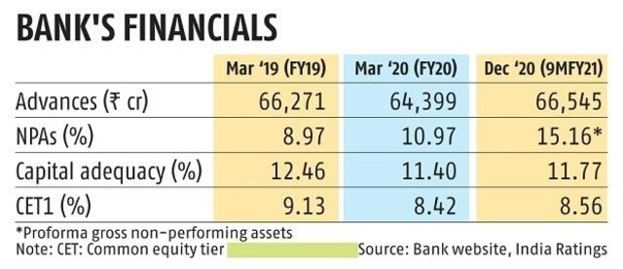

*Table 1.1*

# 

# *J&K Bank in the Top 10 banks that offer the lowest rates on personal loans*

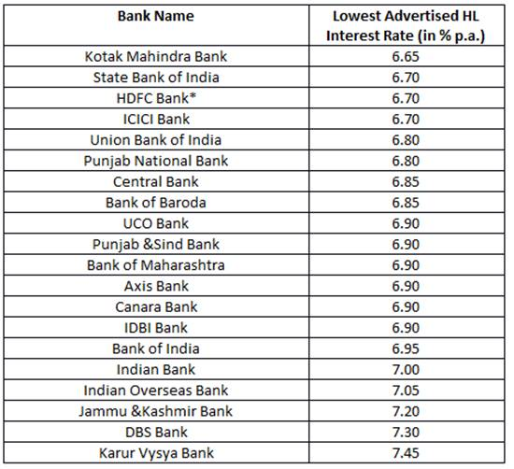

*Table 1.2*

|  |  |  |
| --- | --- | --- |
|  |  |  |
|  |  |  |
|  |  |  |

*Credit to deposit ratio of Jammu and Kashmir Bank in India between financial year 2017 and 2021*

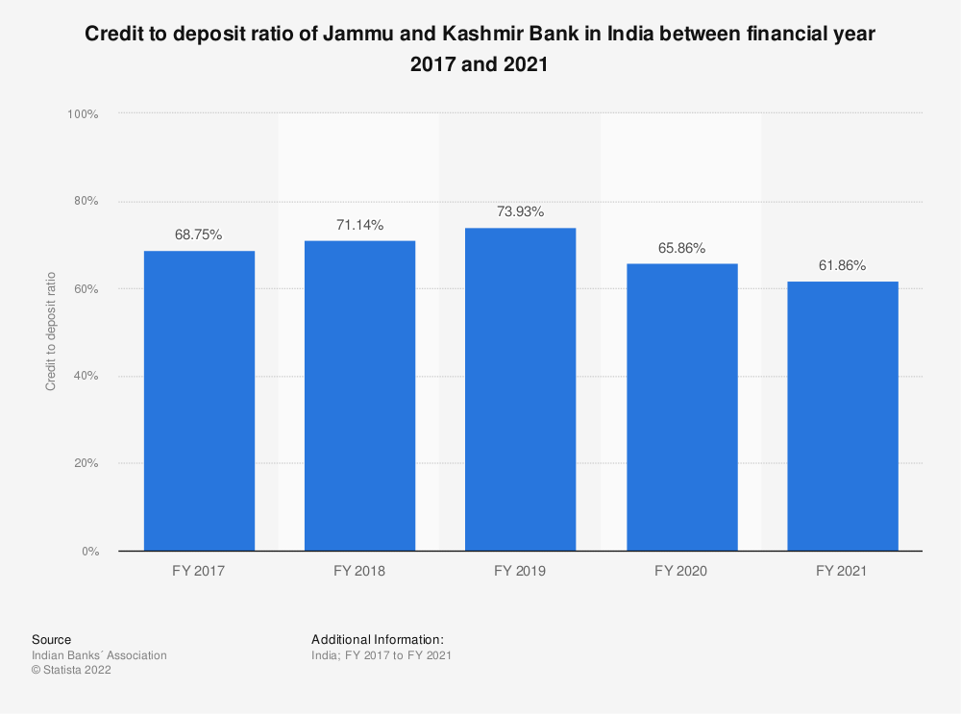

*Fig 1.1*

*Fig 1.1*

*JAMMU AND KASHMIR BANK: FINANCIAL RATIO: BURDEN- TOTAL ASSETS*

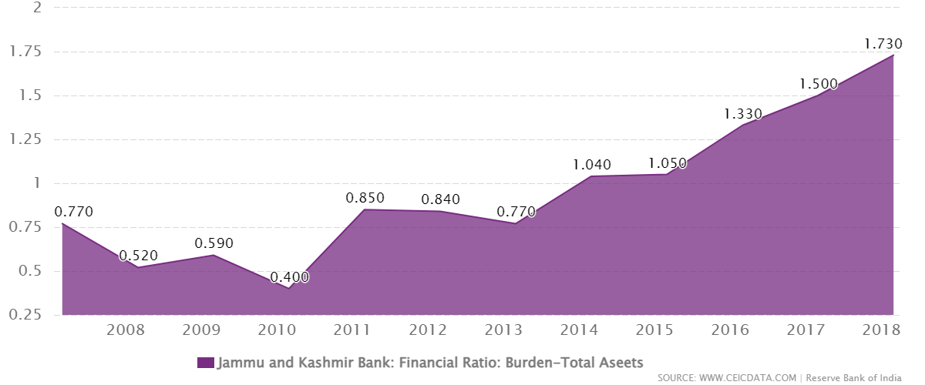

*Fig 1.2*

***4. Case Study***

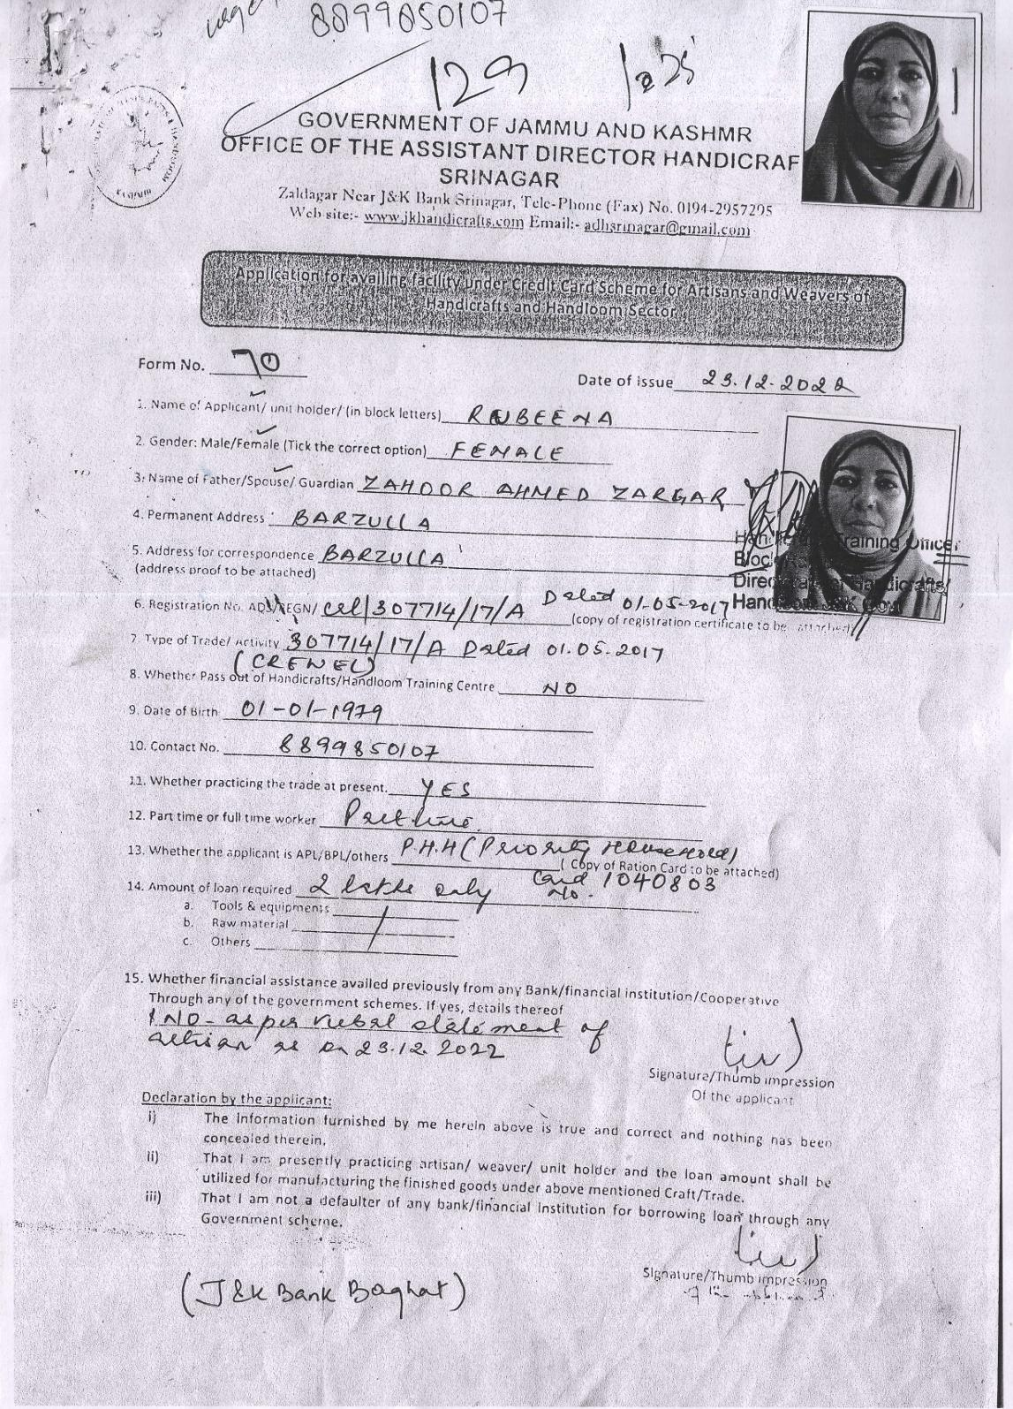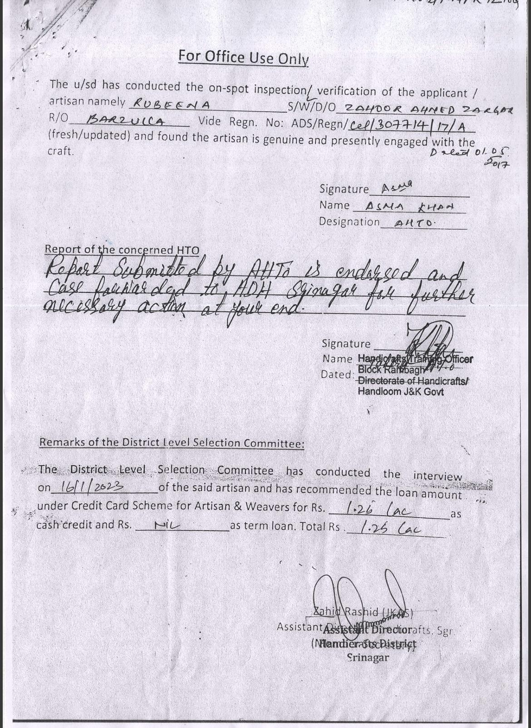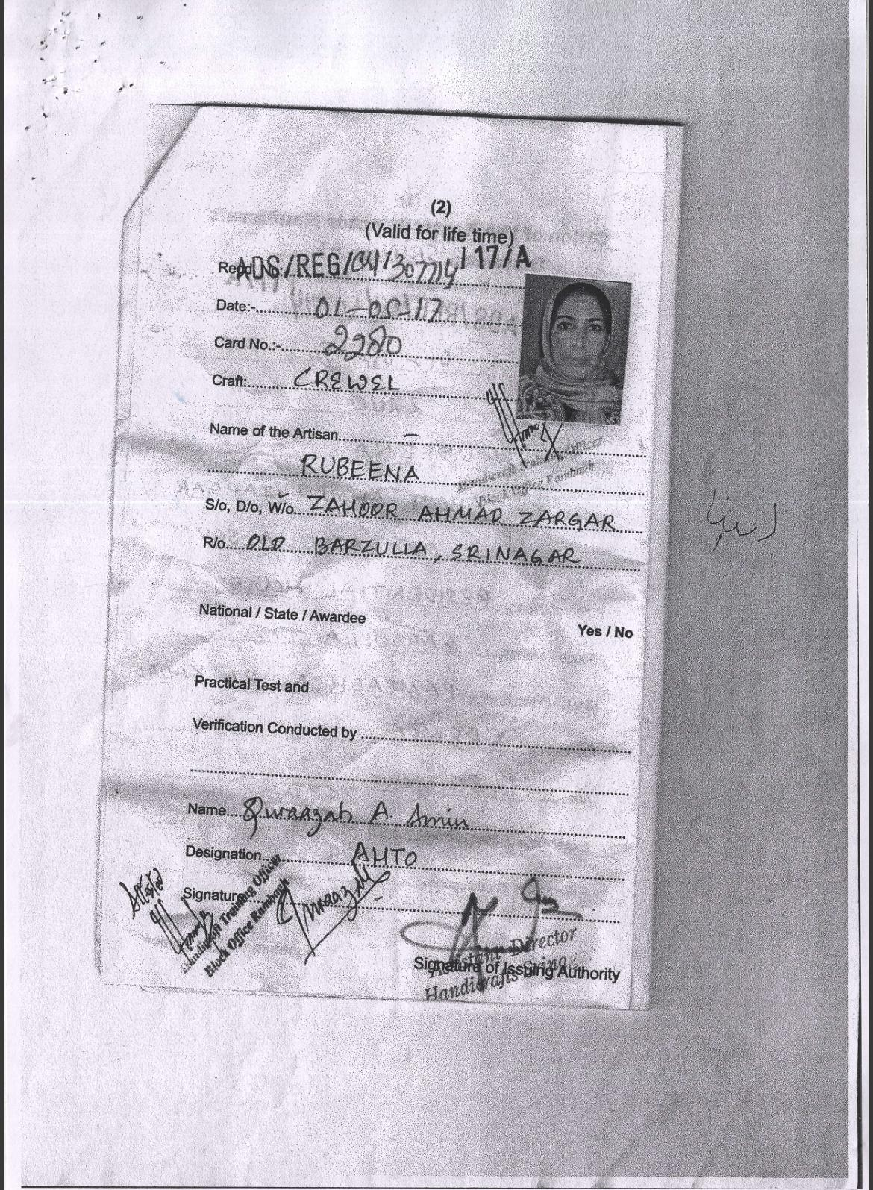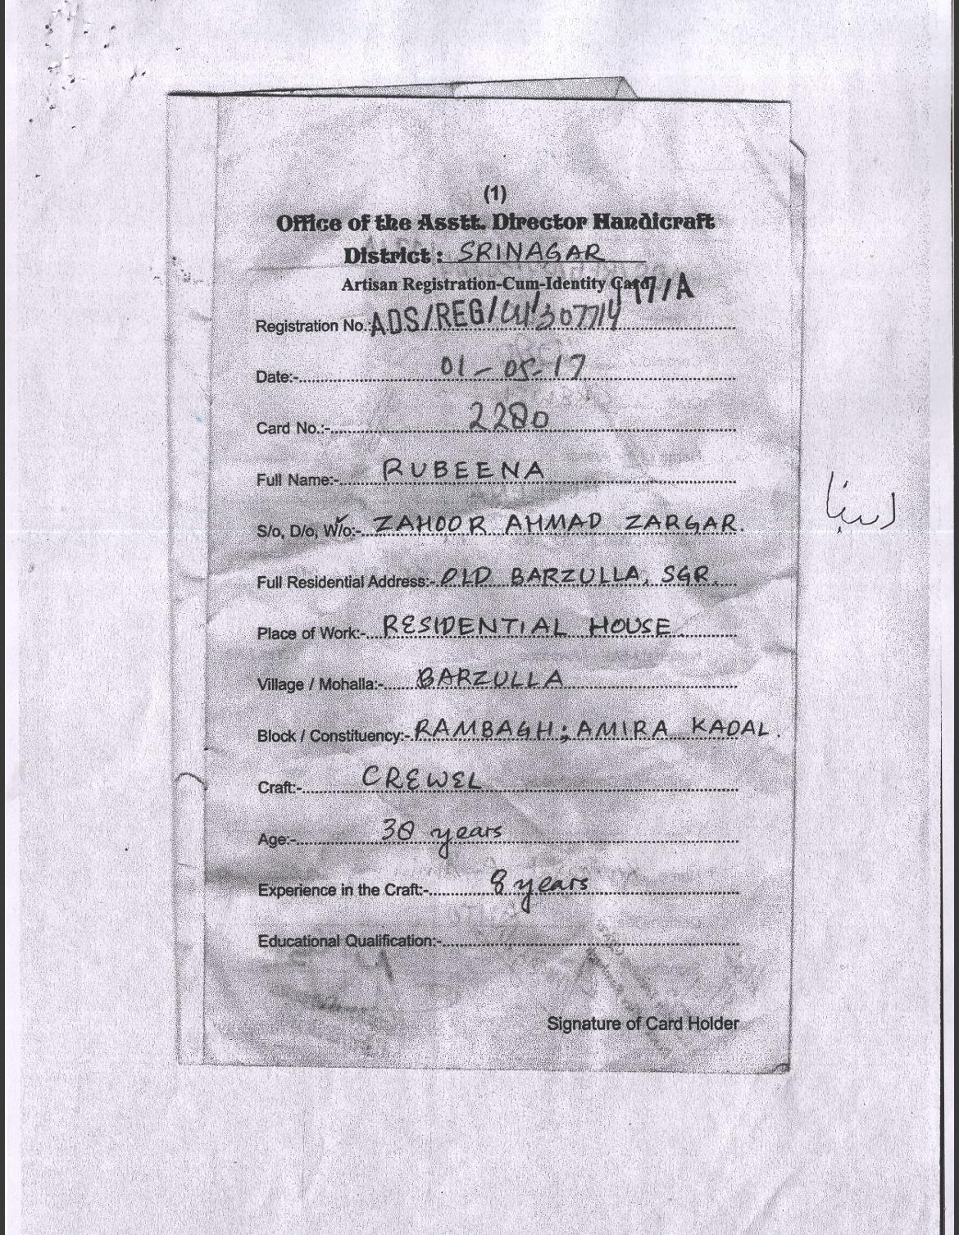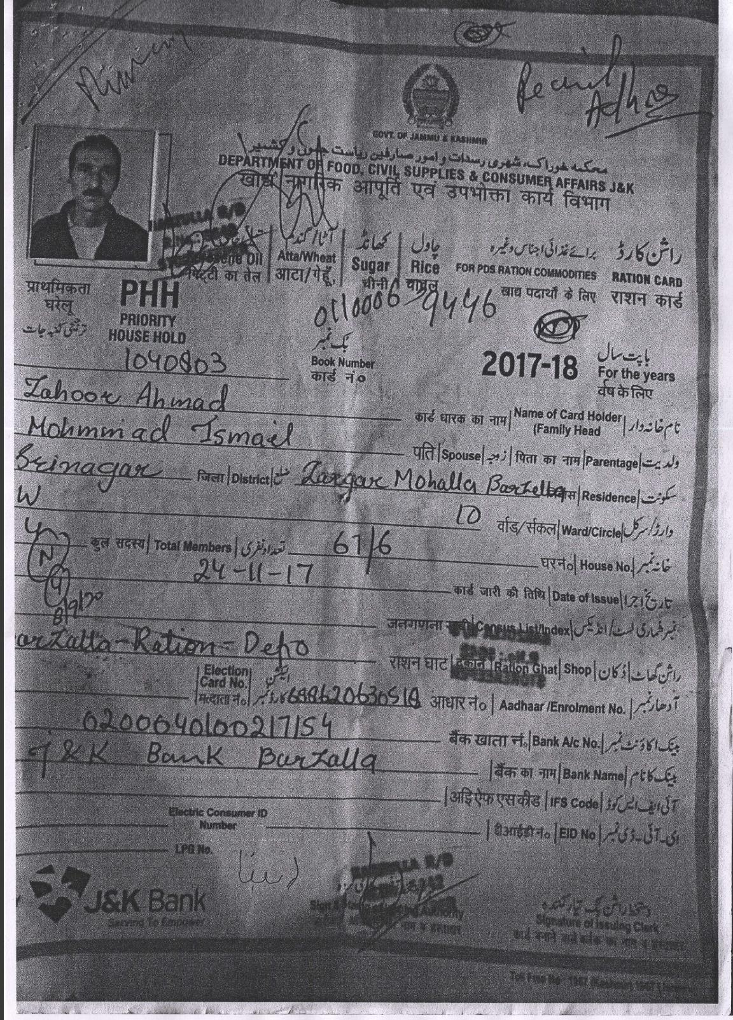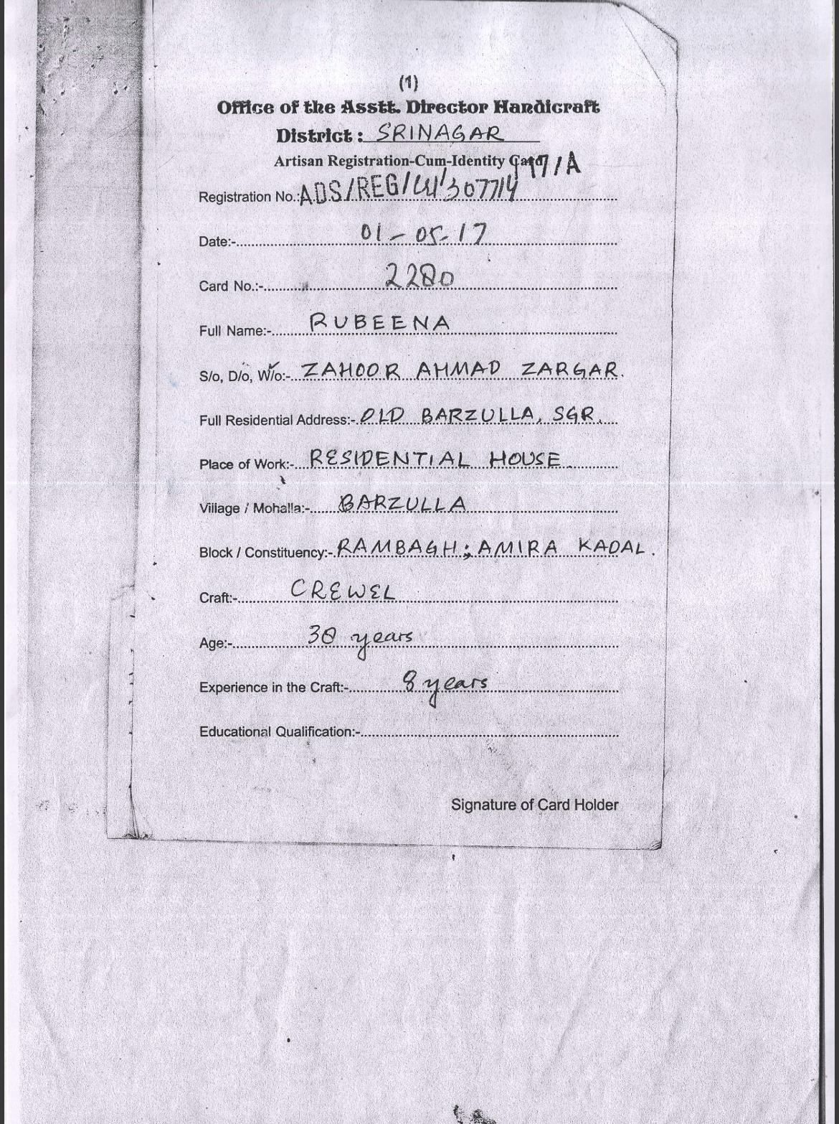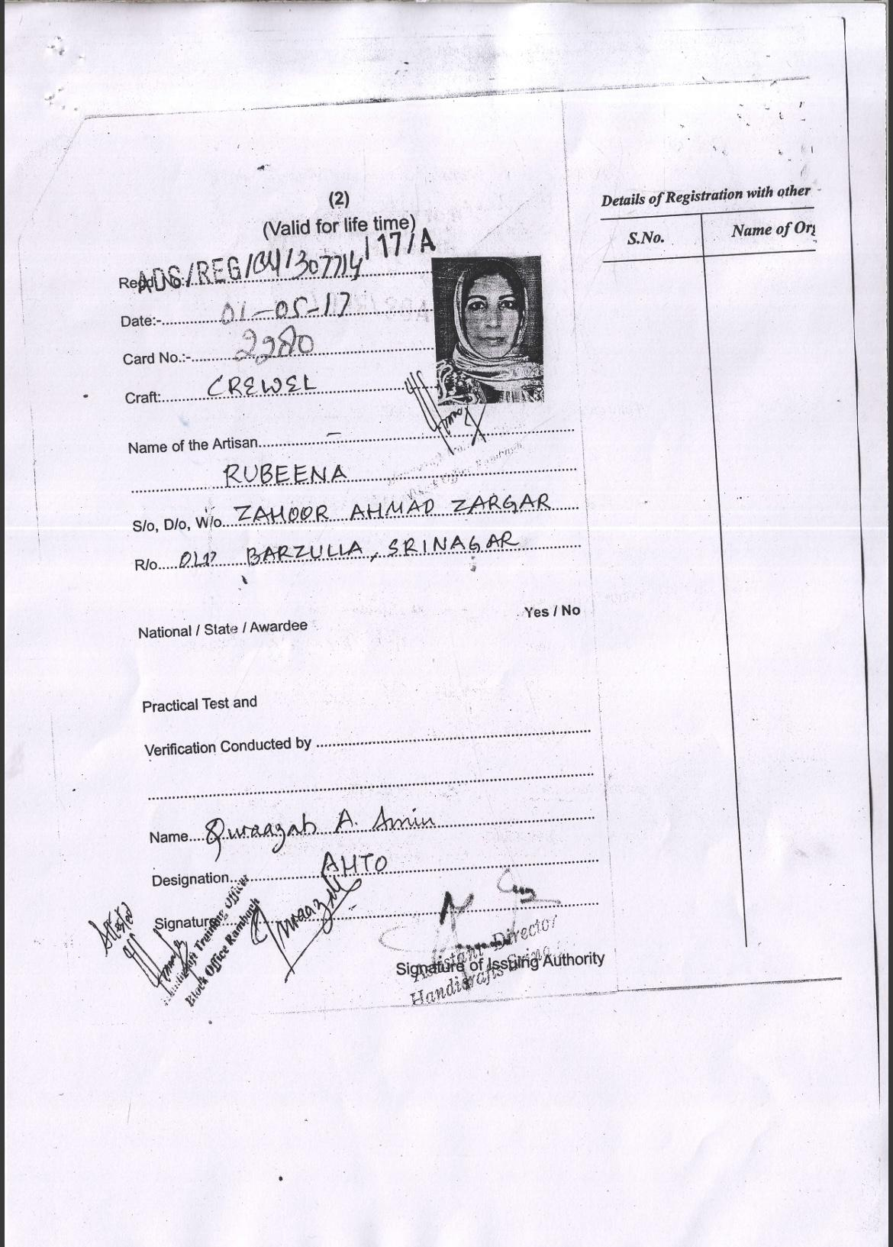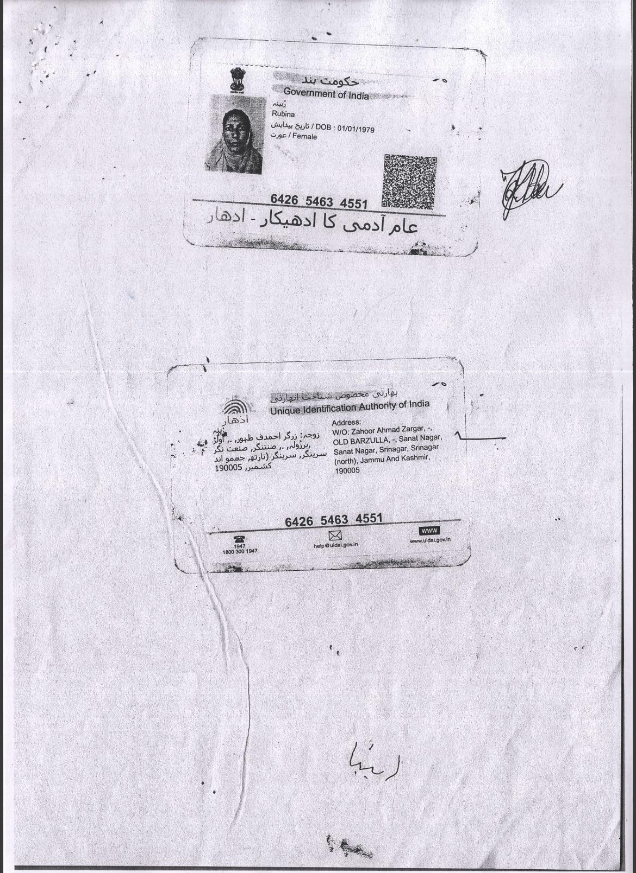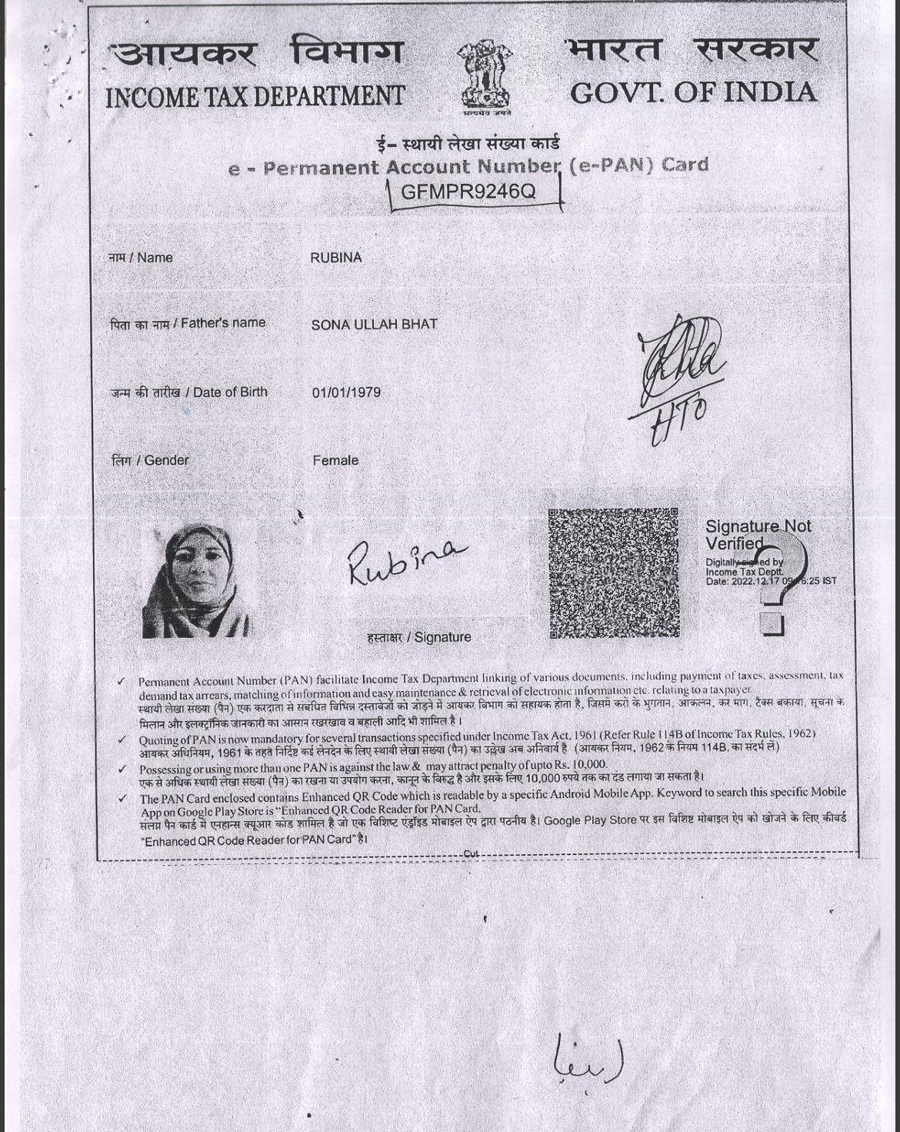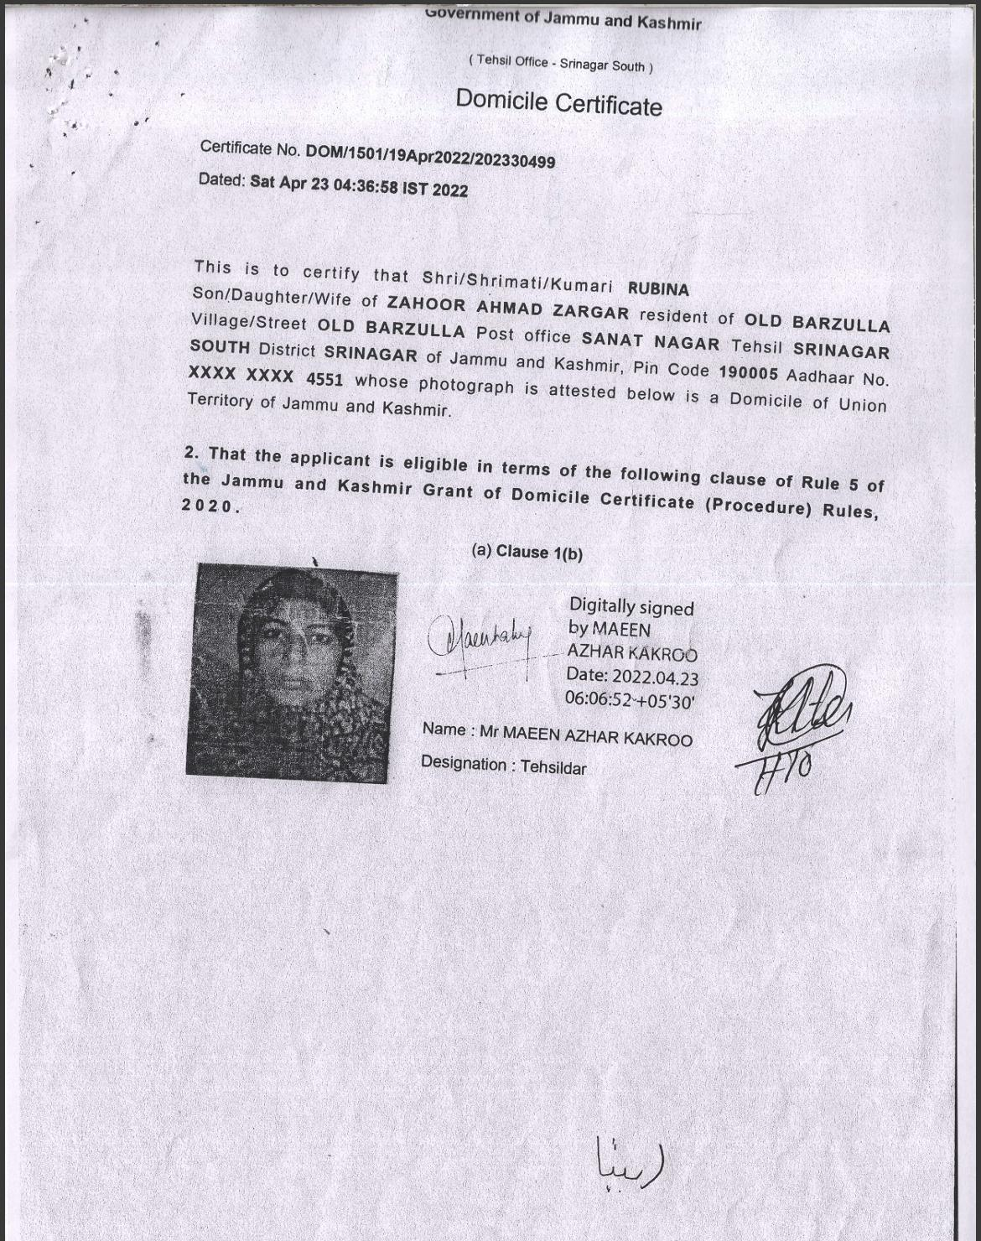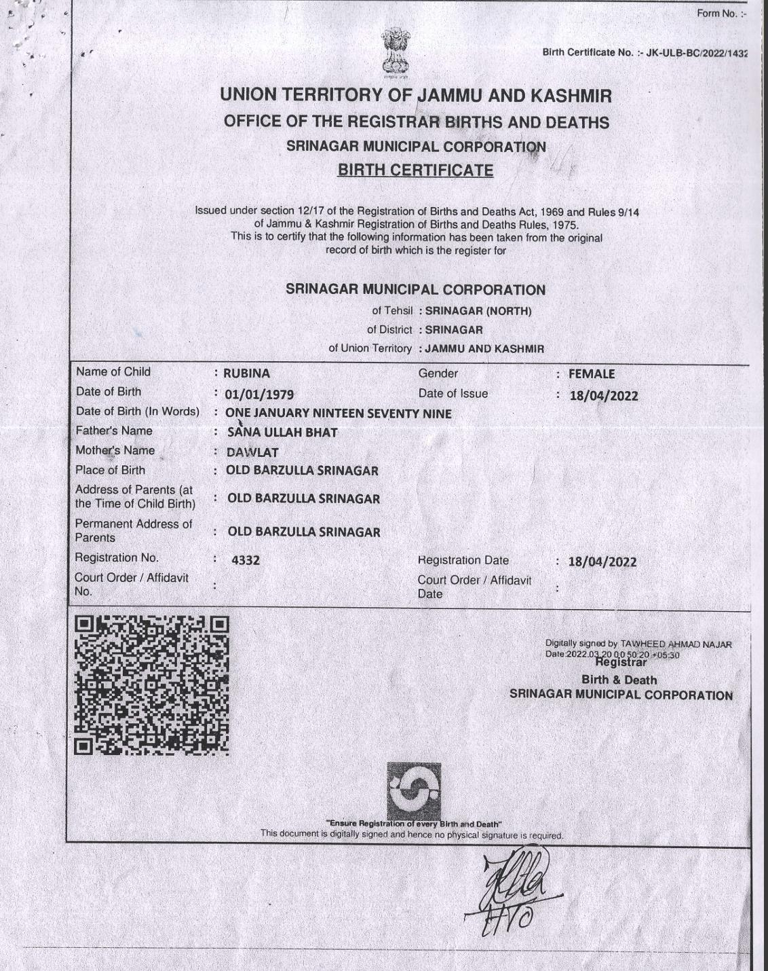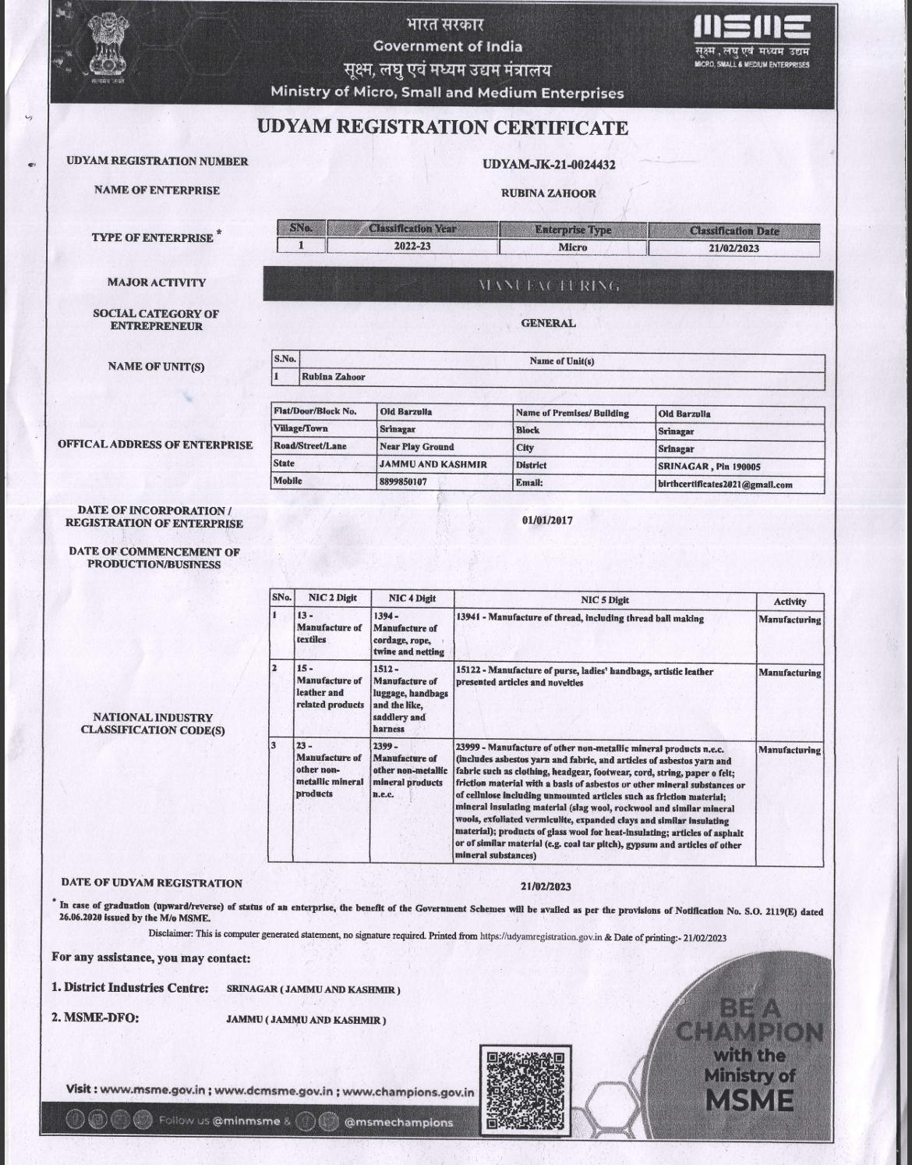

***5. Conclusion***

*In the changing concept of banking, financing in some areas, especially in advances to*

*agriculture, small industries, small borrowers and export oriented industries are assuming great importance. Investment is the most important asset as well as the primary source of earning for the bank. On the other hand this is also the major source of risk for the bank. So the bank should always try to make an appropriate balance between its return and risk involved with the investment portfolio. Close supervision and effective follow up of investment activities might reduce the risk to a great extent. An unsupervised investment might be stuck up. Consequently not only the depositors but also the general shareholders will be deprived of getting back their money from the bank.*

*So as a private bank J&K Bank is trying it’s best to extend its services to the public. J&K Bank, Main Branch provides all kinds of commercial banking services to its customers. Foreign Exchange department is doing well in rending all the services related to international trade and remittance.*

*Though the advance of Main Branch is high, the Credit department will be in a good*

*position if the Branch is able to recover that. General banking is engaged in cash receipt, payment, cheque clearing, opening accounts, deposit scheme, and local remittance etc. So if J&K Bank wants to continue a profitable business and position itself as one of the top banks in the banking arena then it has to earn the trust of their assets and must be concerned about their commitment to the customers.*

*As a concluding remark the Bank is able to attain a leading role with the 85 years success story but to remain unrivaled among new generation banks, the bank must face new challenges. The bank must make a positive attempt to be more outward looking in their goals and aware of what is happening. They must also emphasize the domestic scenario more closely and analyze any certain trends and strategies of their competitors. The bank must accept any failures and think of them as an objective to pursue future goals instead of blaming such failures on other factors and in this way the Bank will be able to keep on playing its important roles in our economy.*

***5.1 Recommendation***

*J&K Bank Limited has been successful in all of its operations since its inception. It has outperformed all its peer and competitor and peer banks in virtually all areas of its activities. Still there is scope for improvement for the bank and the any or all of the following could be which J&K Bank Limited can implement to better its performance:*

* *The bank may employ an outside company for recovery of its dues because it takes a great amount of time for the bank’s employees to recover stuck up loans.*

* *The bank can increase its retail credit loan by allowing credit to more customers. This can be possible through relaxation of credit norms like waiver of guarantee from third parties.*

* *The bank can attract more lease finance customers through reduction of cost of borrowing on the part of the customer. This will provoke customers to repay the loan timely.*

* *The bank can enhance its asset quality through offering rebate on interest rate and hence provocation of timely repayment by the customers. This will be offered only to regular customers.*

* *The loan sanction process can be easier so that the clients can feel convenient to take a loan from the bank.*

* *Consumer loans should be continuing.*

* *Decisions should be decentralized. Manager should be considering the opinion of the subordinate.*

***6. References***

*1. Jammu & Kashmir Bank Limited [Online].*

*Available From* [*https://www.jkbank.com/loans/personal/consumerLoan.php*](https://www.jkbank.com/loans/personal/consumerLoan.php)

*2. Annual Report of Jammu & Kashmir Bank 2019.*